Clause Appositive

🔹 What is Clause Appositive?
# Source: AI Source: Provided by: [Data Path: Persons Table -> ID Column: 1, Name_En Column: Motasem Essam] -> From: [Chatgpt (GPT‑5 Mini)] on [8/7/2025]
A clause appositive is a dependent clause (typically a noun clause) that renames, explains, or identifies a noun in a sentence. It functions just like a regular appositive but takes the form of a clause instead of a word or phrase.

🔸 Key Features:
# Source: AI Source: Provided by: [Data Path: Persons Table -> ID Column: 1, Name_En Column: Motasem Essam] -> From: [Chatgpt (GPT‑5 Mini)] on [8/7/2025]
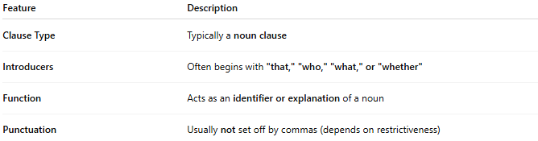
Feature | Description
Clause Type | Typically a noun clause
Introducers | Often begins with "that," "who," "what," or "whether"
Function | Acts as an identifier or explanation of a noun
Punctuation | Usually not set off by commas (depends on restrictiveness)

🔸 Examples:
# Source: AI Source: Provided by: [Data Path: Persons Table -> ID Column: 1, Name_En Column: Motasem Essam] -> From: [Chatgpt (GPT‑5 Mini)] on [8/7/2025]
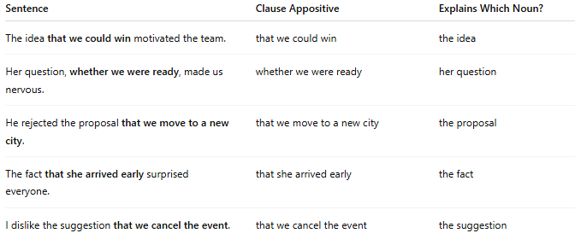
Sentence | Clause Appositive | Explains Which Noun?
The idea that we could win motivated the team. | that we could win | the idea
Her question, whether we were ready, made us nervous. | whether we were ready | her question
He rejected the proposal that we move to a new city. | that we move to a new city | the proposal
The fact that she arrived early surprised everyone. | that she arrived early | the fact
I dislike the suggestion that we cancel the event. | that we cancel the event | the suggestion

